NEWSLETTER July 2022

Research Committee

**Updates**

Did you know UNSW library offers subject guides for 21 different areas? From education to medicine or social sciences, there’s something for every student. Explore the subject guides here: <https://subjectguides.library.unsw.edu.au/subjectguides>

**Events**

**Recordings and slides from all our Postgraduate Week workshops can be found here, thanks everyone for coming!**

[**https://arcunsw.sharepoint.com/Transfer/Shared%20Documents/Forms/AllItems.aspx?id=%2FTransfer%2FShared%20Documents%2F1%2E%20Digital%20Assets%20%2D%20Transfer%2F2022%2FPGC%2FPostgrad%20Fest%2FPGF%20Event%20Recordings&p=true&ct=1656043561641&or=OWA%2DNT&cid=40cf621c%2D04e7%2D5406%2D86b2%2D39bf5139bf11&ga=1**](https://arcunsw.sharepoint.com/Transfer/Shared%20Documents/Forms/AllItems.aspx?id=%2FTransfer%2FShared%20Documents%2F1%2E%20Digital%20Assets%20%2D%20Transfer%2F2022%2FPGC%2FPostgrad%20Fest%2FPGF%20Event%20Recordings&p=true&ct=1656043561641&or=OWA%2DNT&cid=40cf621c%2D04e7%2D5406%2D86b2%2D39bf5139bf11&ga=1)

**External events**

The UNSW Visualise your thesis competition closes 15th July! Apply here for your chance to win $1,000 <https://unsw.sharepoint.com/sites/unswhdr/SitePages/UNSW-Visualise-Your-Thesis-Competition.aspx>

Coursework Committee

**Updates**

**Events**

**External events**

International Committee

**Updates**

The PGC international office is calling for expressions of interest to fill the position of International Committee Liaison. If you are an international student, a current member of Arc @ UNSW, and you are thrilled to enrich yours and other’s experiences at UNSW, please apply here:

<https://www.arc.unsw.edu.au/pgc/vacant-positions-1>

Our brochure for UNSW International Postgraduate Students is now available online for download. Find all services and programs tailored to your needs as an international student to elevate your experience at UNSW.

<https://unsw.sharepoint.com/:b:/s/PGC2022/ERzdOY7LU7pMoUm-IxifMYoB1yjqxvNmuTQfbBYWvCqRog?e=c45GdU>

**Events**

The UNSW Postgraduate Council have partnered with the Hong Kong Australia Business Association (NSW Chapter) to bring you a bespoke workshop giving you practical tips to help you identify and reach your career goals.

Refreshments and Drinks will be served.

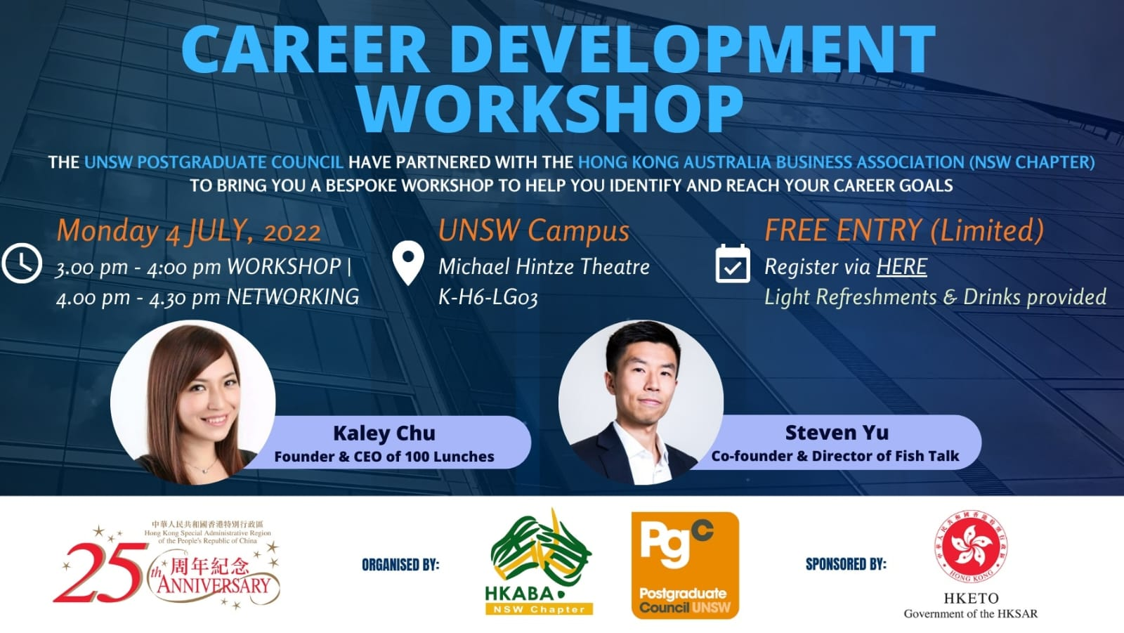

**Register here:**

<https://www.eventbrite.com.au/e/pgc-x-hkaba-career-development-workshop-tickets-370794966727>

This event aligns with Sustainable Development Goals #8

**External events**

Equity Committee

**Updates**

Post- grad fest was a huge success with our Equity team collaborating with Arc to host 3 events: Post-grads and parenting, wine and cheese night, and a mental health panel.

**Events**

On the 7th July from 5:30pm we will be hosting a movie night at the Ritz Cinemas in Randwick. Use the link to sign up and get tickets!!

<https://www.eventbrite.com.au/e/pgc-movie-night-at-the-ritz-tickets-372592733897>



**External events**